STANDARD OPERATING PROCEDURE
Merchant Fees Preparation
Shopify Payments PayPal · Afterpay
Process | Merchant Fees Preparation
Platforms | Shopify Payments · PayPal · After pay
Tools used | Shopify · PayPal · After pay · ChatGPT / Claude (Agent mode) · Excel
Frequency | Weekly / Monthly
Document Owner | ________________________
Version / Date | ________________________

1. Purpose
We need to prepare the Merchant Fees report so that fees for each platform are recorded separately for each date. We use ChatGPT or Claude to prepare the same.

2. Scope
This procedure covers the end-to-end preparation of the Merchant Fees report for the three payment gateways used on the store — Shopify Payments, PayPal and Afterpay. It includes downloading the required source reports from each platform, generating the order-level fee sheets using ChatGPT (Agent mode), and verifying that the gross sales tie back to Shopify’s Net Payment by Gateway summary.

3. Inputs Required
The following reports are required to prepare the Merchant Fees:
- Shopify – Net Payment by Order
- Shopify – Total Sales by Order
- Shopify – Payment Transactions report
- PayPal – PayPal Activity report
- Afterpay – Afterpay Settlement report

Steps to Download the Required Files
First, log in to Shopify:
https://admin.shopify.com/store/qtat02-wj/payments/payouts/transactions?payout_date_min=2025-11-02&payout_date_max=2025-11-02
Username: Nikhar.m@gatpsolutions.com
Password: Saved in LastPass

Shopify – Net Payments by Order
- Go to Analytics > Reports.
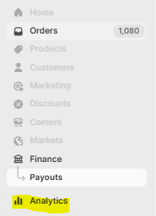
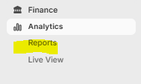
- Select “Net Payments by order”.
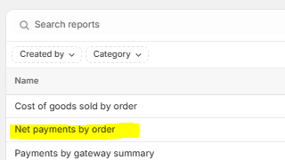
- Select the date range and click Apply. (Merchant fees are recorded on a weekly basis, so choose the dates carefully.)
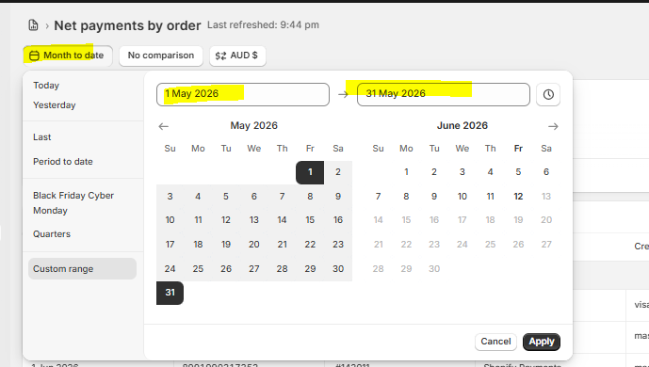
- Click the three dots and click Export.
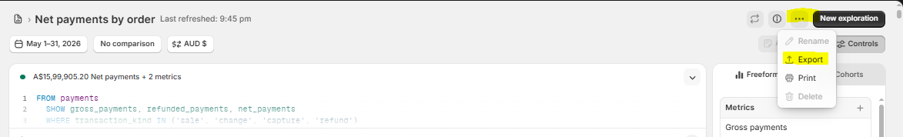
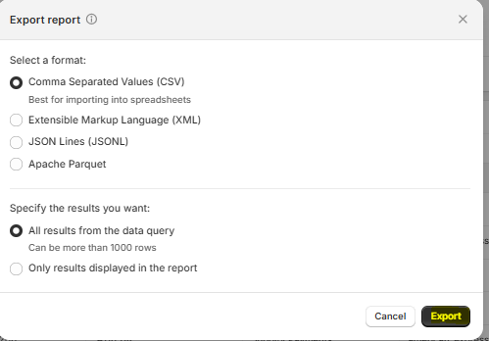

Shopify – Total Sales by Order
- Go back to the Reports tab, select “Total Sales by order”, choose the same date range as the Net Payments by order report, and export it.
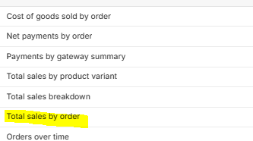
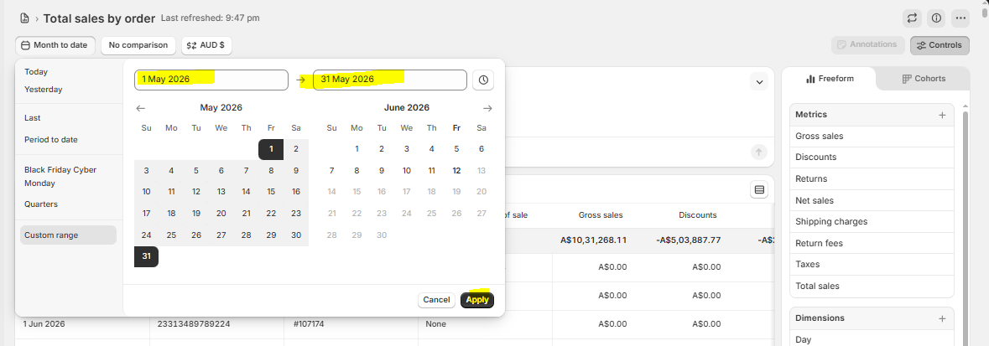
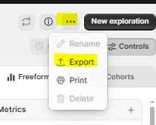
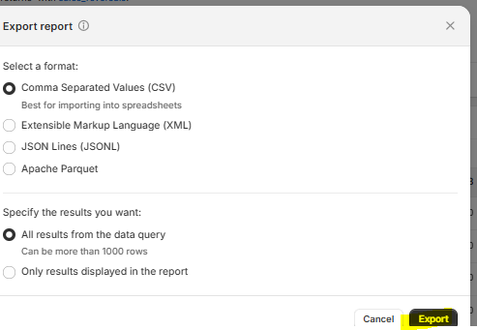

Shopify – Payment Transactions Report
- Go to Finance.
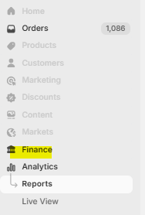
- Select “View order transactions”.
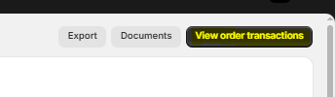
- Apply a filter on Date.
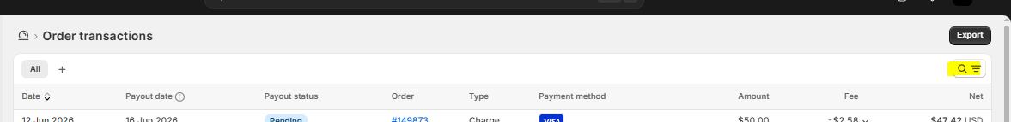
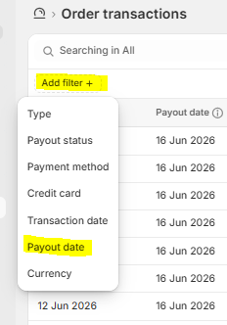
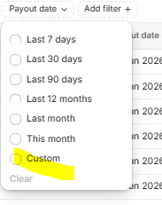
- Select the date range and click Export. The report will be received on the team ID and may take some time.
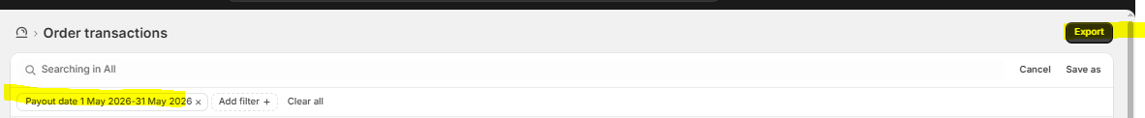

PayPal – Activity Report
- Log in to PayPal (credentials are saved in the Credential sheet; the report link is available from the Slack channel Overview). It will ask for an OTP — you can get that from the accounting ID.
- Once logged in, click Activity and select All transactions.
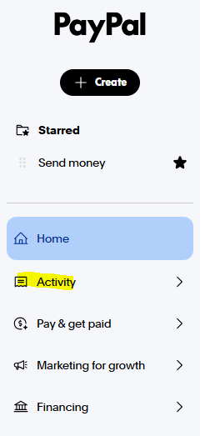
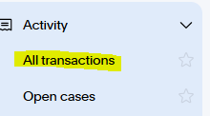
- Click the Download option.
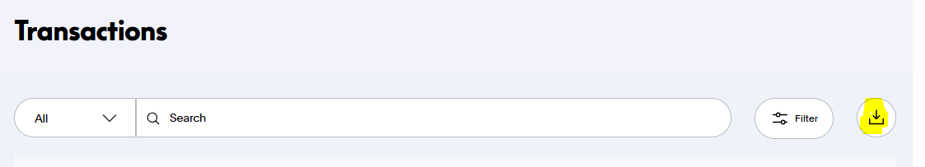
- Select the date range and create the report.
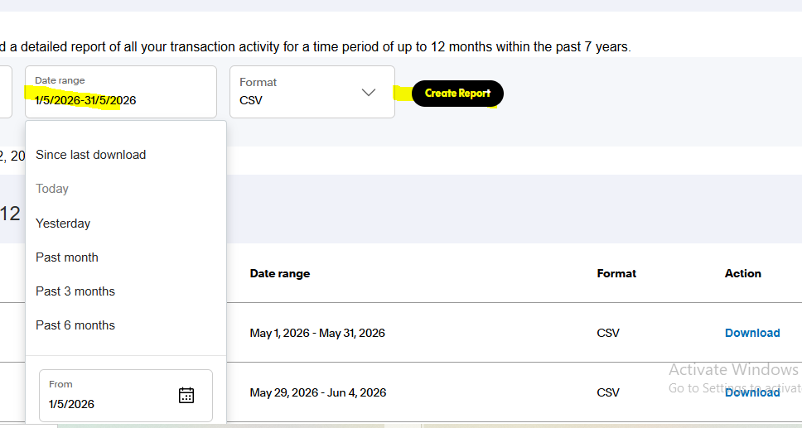
- The report will be available on the same portal — download it from there.

Afterpay – Settlement Report
- Log in to Afterpay (credentials are saved in the Credential sheet; the report link is available from the Slack channel Overview). It will ask for an OTP — you can get that from the accounting ID.
- Once logged in, click Finance > Reconciliation.
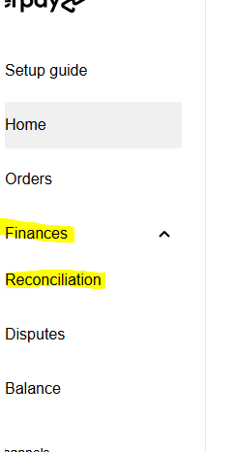
- Click Export report.
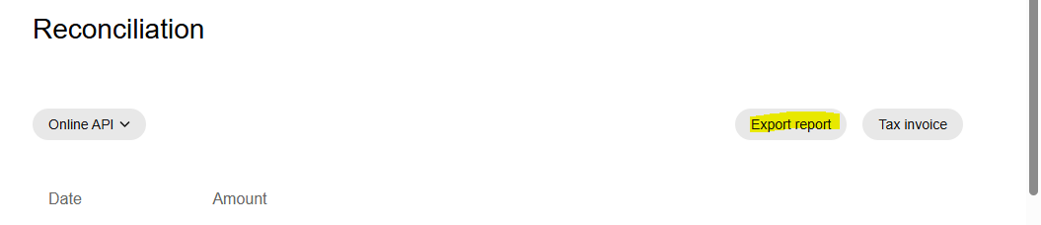
- Select the date range and click Download.
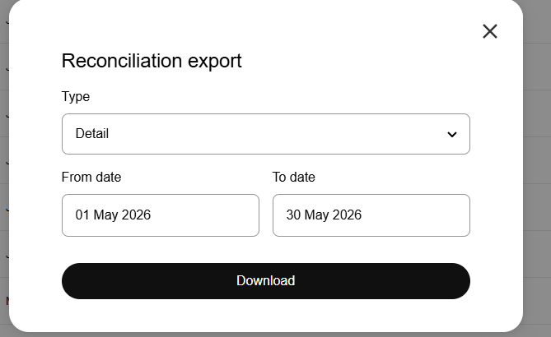
Once you have all the required files for each platform, place them together in one folder.

4. Process to Prepare Merchant Fees
Merchant Fees are prepared using Chatgpt in Agent mode — https://chatgpt.com/
- Click + > More > Agent mode.
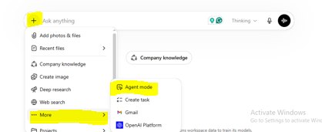
Give ChatGPT the prompt below, along with all the files you downloaded. Also, make sure to specify the following:
- Prepare the merchant fees for the relevant month (mention the exact date range you are working on).
- Each platform must contain fees separately for each date.
- The Gross Sales must match the Net Payment in the Net Payments by order report.
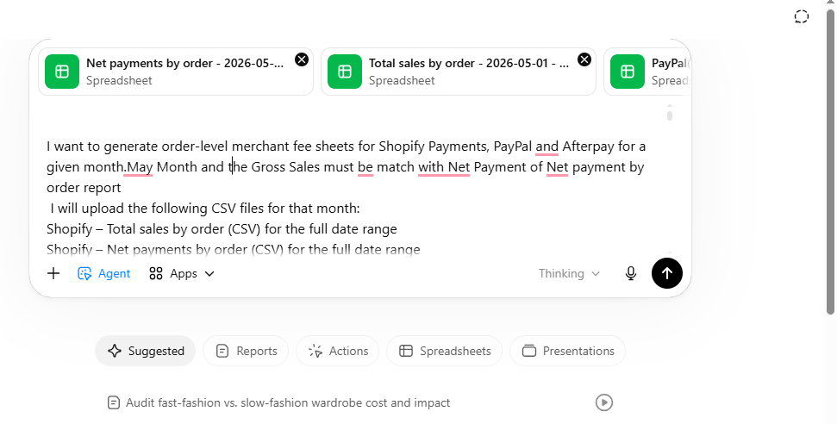

Reusable Prompt – Monthly Merchant Fee Sheets (Shopify / PayPal / Afterpay)
Copy the prompt below and paste it into ChatGPT (Agent mode) together with all downloaded files:
INSTRUCTIONS FOR CHATGPT – MERCHANT FEES ONLY (NO JEs)
I want to generate order-level merchant fee sheets for Shopify Payments, PayPal and Afterpay for a given month. I will upload the following CSV files for that month:
Shopify – Total sales by order (CSV) for the full date range
Shopify – Net payments by order (CSV) for the full date range
Shopify Payment Transactions export (CSV) – includes Shopify Payments fees & GST
PayPal activity report (CSV) for the same period
Afterpay settlements report (CSV) for the same period
I will also tell you:
The date range (e.g. 2-Nov-2025 to 30-Nov-2025)
Optionally, an order range (e.g. #10053–#10342), and you must only use orders within that range for those days
1. Core rules
Treat Shopify Net payments by order as the source of truth for:
Which orders exist
The Order ID (use Order name, e.g. #10053)
The gateway used: Shopify Payments, PayPal, Afterpay
If an order appears in other files but not in Net payments, ignore it.
If I give you an order range (e.g. #10053–#10342), only include orders whose Order name falls in that range.
For each day and gateway, the sum of allocated fees must reconcile to:
Shopify: the Payment Transactions export
Afterpay: the settlements report
PayPal: the PayPal activity report (after FX conversion)
Order ID column must always be the Shopify Order name.
2. Gateway-specific logic
2.1 Shopify Payments
Use the Payment Transactions export:
Filter to the requested date range and Type = charge (or other fee-bearing transaction types, exclude balance transfers/payout summaries).
Clean numeric columns (Amount, Fee, Net, GST).
For each day:
Sum Fee incl GST and GST to get daily Shopify fee totals.
Fee ex-GST = Fee incl GST − GST.
For each order paid via Shopify Payments:
Use Net payments report to identify the order, its Order name and its gross payments.
Within each day, allocate the total Shopify fee ex-GST and GST pro-rata by that order's share of daily gross payments (after any refunds).
Make sure the daily sum of allocated Shopify fees = daily total from the Payment Transactions export (fix 1–2 cent rounding differences on a single row if needed).
2.2 Afterpay
Use the Afterpay settlements report:
Clean $ and commas from Order Amount, Merchant Fee excl Tax, Merchant Fee Tax, Merchant Fee incl Tax, Net Settlement Amount.
Parse Settlement Date as a proper date and filter to the requested range.
Include both Order and Refund rows, with the correct sign.
For each day:
Compute total Merchant Fee excl Tax, Merchant Fee Tax (GST) and Merchant Fee incl Tax.
For order-level allocation:
Use Net payments to get all Shopify orders with Payment gateway containing "Afterpay".
Restrict to the order range if I've specified one (e.g. #10053–#10342).
For each day, calculate each Afterpay order's share of that day's gross payments minus refunds (from Net payments).
Allocate Merchant Fee excl GST, GST, and Merchant Fee incl GST pro-rata to each order.
Ensure daily totals of allocated fees match the settlements report (adjust tiny rounding differences to one row).
2.3 PayPal
Use the PayPal activity CSV:
Parse Date (day-first if needed).
Clean numeric columns for Gross, Fee, Net.
Identify sales (positive Gross) and refunds (negative Gross).
Currency conversion:
Convert all amounts to AUD using Reserve Bank of Australia (RBA) or similarly reputable historical FX rates for each transaction date and currency (USD, GBP, CAD, NZD, etc.).
For each day:
Compute total Gross receipts (AUD), Refunds (AUD) and Fees (AUD) from PayPal.
Derive an average fee rate for sales (and treat refund fees as part of the same fee pool).
PayPal fee tax:
PayPal merchant fees are GST-exempt – no GST splitting needed.
Fee allocation to orders:
Use Net payments to identify orders with Payment gateway containing "PayPal".
Apply order range filter if provided.
For each day, allocate the total PayPal fee (AUD) across those orders pro-rata by their gross payments minus refunds from Net payments.
Ensure that the sum of allocated PayPal fees per day = total PayPal fees per day from the PayPal report (adjust rounding on one row if needed).
3. Required outputs (Excel fee sheets only – no JEs)
Please generate three Excel workbooks:
3.1 Shopify_fee_details_[MONTH].xlsx
One sheet, e.g. "Shopify Fees", with columns:
Date
OrderID (Shopify Order name like #10xxx – this is mandatory)
GrossAmountAUD (Shopify Payments gross for that order on that date)
FeeExGST
GSTOnFee
FeeInclGST
NetAmountAUD (Gross − FeeInclGST)
3.2 Afterpay_fee_details_[MONTH].xlsx
One sheet, e.g. "Afterpay Fees", with columns:
Date
OrderID (Shopify Order name)
GrossAmountAUD (positive for sales, negative for refunds)
MerchantFeeExclGST
MerchantFeeGST
MerchantFeeInclGST
NetAmountAUD (GrossAmountAUD − MerchantFeeInclGST)
3.3 PayPal_fee_details_[MONTH].xlsx
One sheet, e.g. "PayPal Fees", with columns:
Date
OrderID (Shopify Order name)
OriginalCurrency
GrossOriginalCurrency
GrossAmountAUD
FeeAmountAUD
NetAmountAUD (GrossAmountAUD − FeeAmountAUD)
Type (e.g. "Sale", "Refund")
For each workbook, check and state explicitly that:
Daily fee totals per gateway reconcile to the underlying source reports (Shopify Payment Transactions, Afterpay settlements, PayPal activity).
If any 1–2 cent rounding adjustments are made, note which day and which row was adjusted.
When you're done, give me:
A short summary table of total fees per gateway for the month, and
Download links for all three Excel workbooks.
Once ChatGPT completes the process, it will provide three Excel files. Download all of them.
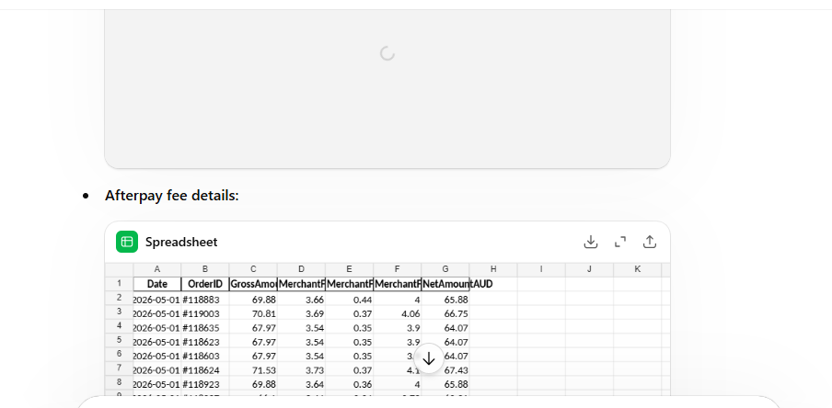

5. Verification – Matching Gross Sales
Open the files one by one and match the Gross Sales amount shown in the Merchant Fees sheet against the Net Payment by Gateway in Shopify.
- Go to Shopify > Analytics > Reports > Net payment by gateway summary.
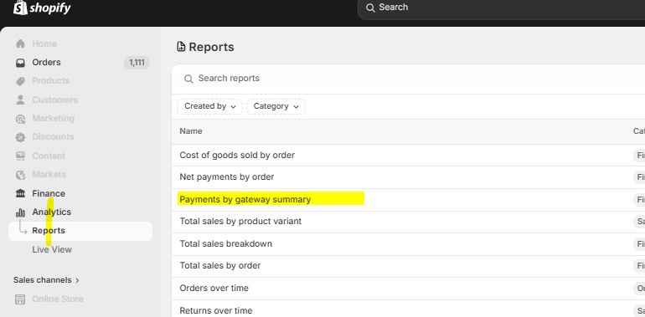
- Select the date range for the period you are preparing the fees for.
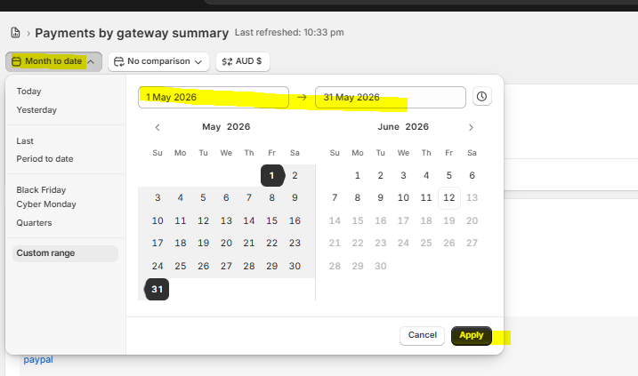
- Confirm that the Gross Sales in the Shopify Merchant Fees sheet match the Net Payment by Gateway summary.
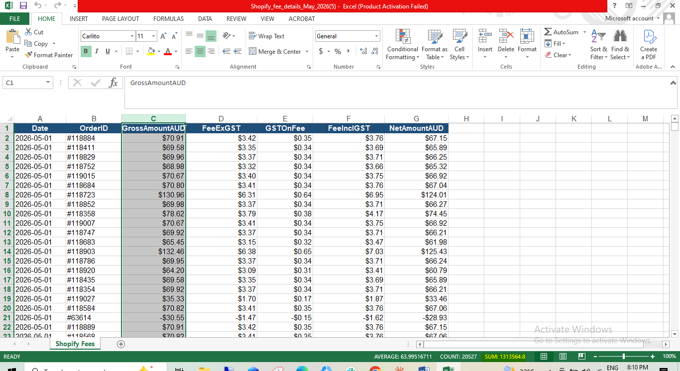
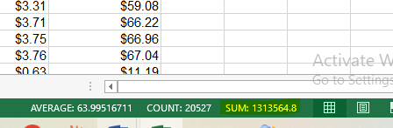
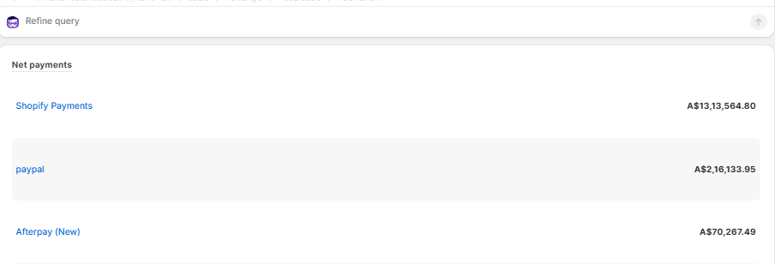
Repeat the same matching for the total of each platform. If there is a variance in any total, give the corrected instructions to ChatGPT and ask it to provide an updated sheet.

Update Merchant Fees in Xero

After preparing the merchant fees, we need to record them in Xero. Follow the steps below
Step 1: Login Xero Link
Username - Nikhar.m@gatpsolutions.com
Password - Saved in Lastpass
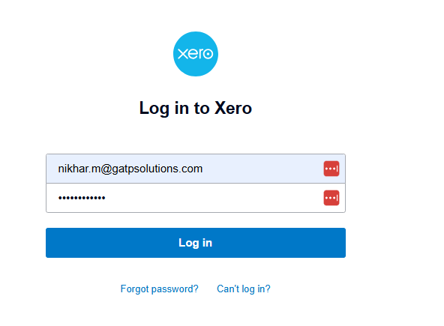

Will ask for OTP, and ask HR for the same

Step 2: Now, on the Dashboard, go to Accounting > Manual Journals
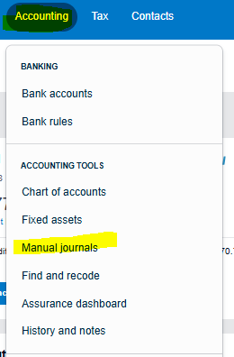

Step 3: Click on New Journal
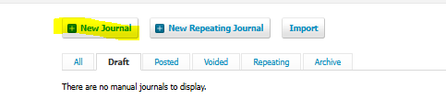

Step 4: Update the detail as per the screenshot below
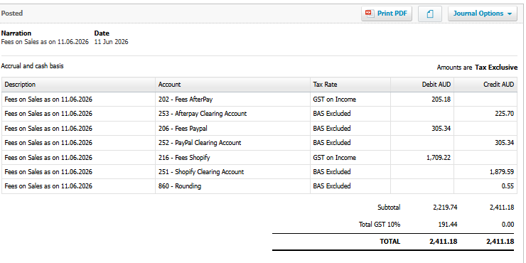

Update Merchant fees in the daily reporting sheet
We need to add the total of merchant fees (All Platform fees) in the Merchant fees row in the daily reporting sheet
